
FACULTY OF TECHNOLOGY AND ENGINEERING
DEVANG PATEL INSTITUTE OF ADVANCE TECHNOLOGY
AND RESEARCH

DEPARTMENT OF COMPUTER ENGINEERING

A.Y 2026 – 27 Semester – 3

LAB MANUAL

CSUC201 Fundamentals of Data Structures and Algorithms

Practical 6: Stack Implementation using Array and Linked List, with Expression Processing
Practical Aim :
To implement stack using array and linked list, and apply stack-based logic to expression conversion, evaluation, and bracket validation problems.
Problem 1 :
A cafeteria stacks clean trays on a fixed-size counter. New trays are always placed on top, and customers always take from the top. The counter can hold at most n trays at a time — if it is full, no more trays can be added, and if it is empty, no tray can be taken. Given a sequence of place and take operations, implement this fixed-capacity tray stack and print the current top tray after each operation. Report an error if a place or take operation cannot be performed. Describe how your solution tracks whether the stack is full or empty. What are the exact conditions you check before a push and before a pop, and what does your program do when those conditions fail?
For Code:

https://github.com/kvvaghasiya49/FDSA/tree/6fb2f463bf1f58ac 408ada5ca8ffdaa64bc82087/DSA

Output:
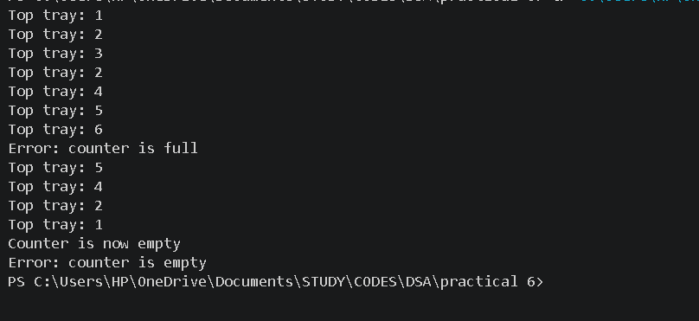
Problem 2 :
A web browser keeps track of pages visited so that the back button always returns to the most recently visited page. Unlike a fixed counter, the browser has no hard limit on how many pages it can remember — it grows as the user visits more pages and shrinks as they press back. Given a sequence of visit and back operations, implement this unlimited page history and print the current page after each operation. Describe how your solution differs from Problem 1 in how it handles memory. What happens in your solution when the user presses back on the very first page with no history left?

For Code :

https://github.com/kvvaghasiya49/FDSA/tree/6fb2f463bf1f58ac 408ada5ca8ffdaa64bc82087/DSA

Output :
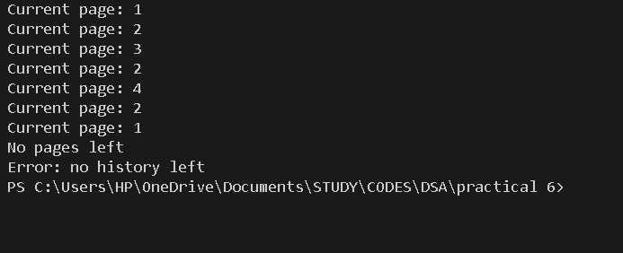

Problem 3 :
A calculator application receives arithmetic expressions typed by users in the usual way — numbers and operators written in between, with brackets to control priority (e.g. 3 + 4 * 2 or (3 + 4) * 2). Internally the calculator needs to convert each expression into a form where operators appear after their operands, so it can evaluate them without needing to re-read brackets. Given an infix expression, convert it to the equivalent postfix form and print the result.
Describe the role the stack plays in your conversion. What does your solution do when it encounters a closing bracket, and what happens to the operators that were waiting on the stack at that point?
Code :

https://github.com/kvvaghasiya49/FDSA/tree/6fb2f463bf1f58ac 408ada5ca8ffdaa64bc82087/DSA

Output :

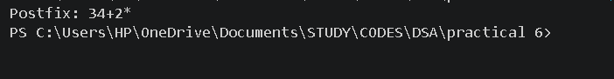

Challenges Faced:
In the array stack, the main difficulty was the full and empty conditions. I had to check top == n-1 before every push and top == -1 before every pop, otherwise the program wrote outside the array or read a value that was not there. In the linked list stack, I had to remember that push and pop both happen at the head, and that popping the last node must set the head to NULL and free that node. For the browser history, pressing back on the very first page needed a separate check so the program shows an error instead of crashing.

Learning Outcomes:
- I learned how to build a stack using an array with a fixed size and using a linked list with no fixed size.
- I understood that overflow and underflow checks must be done before push and pop, so the program does not crash.
- I learned that an array stack has a fixed capacity, while a linked list stack grows and shrinks as needed but uses extra memory for the links.
- I learned how a stack helps in infix to postfix conversion by holding operators until the right time to output them, using precedence and brackets.

Key Questions / Analysis / Interpretation to be Evaluated During/After Implementation :
1. [Problem 1] A circular array is one way to reuse freed slots without shifting all elements. Without implementing it, explain what change would need to be made to your front and rear pointer logic to make the array behave circularly, and what new condition would indicate a full array.

The front and rear pointers should wrap around to the beginning when they reach the end of the array.
Use (rear + 1) % size and (front + 1) % size to move the pointers circularly.
The array is full when (rear + 1) % size == front.

2. [Problem 2] Your linked list stack has no fixed capacity limit. But in practice, can it still run out of space? What determines the actual limit, and why is that limit invisible in your code?
A linked list stack can still run out of space when the system’s available memory is exhausted.
The actual limit depends on the computer’s RAM and available memory.
This limit is invisible in the code because memory is allocated dynamically at runtime.

3. [Problem 3] operator precedence determines the order in which operators are placed into the output. Without tracing any expression, explain what would go wrong in your output if your solution treated all operators as having equal precedence.
If all operators had equal precedence, the expression would not follow the correct order of operations.
For example, A + B * C might be processed as (A + B) * C instead of A + (B * C).
This would produce an incorrect postfix expression and therefore an incorrect result.

